Pizza Sales Analysis Report 2015
An End-to-End Data Analysis using SQL, Python, Excel & Tableau

Mehedi Hasan Data Analyst
May 2026
SQL | Python | Excel | Tableau

1. Executive Summary
Pizza Sales Analysis 2015 examines a full year of transaction data from a pizza restaurant. The dataset contains 48,620 records across 20 columns, capturing detailed information about orders, pizza types, sizes, pricing, and customer behavior. The analysis was conducted using SQL for data extraction, Python for data cleaning and EDA, Excel and Tableau for interactive dashboards.
Key findings reveal that the business generated $817,860 in total revenue from 21,350 unique orders with 49,574 pizzas sold. Friday is the busiest day and Lunch is the peak time of day. Classic category leads in revenue and quantity, while Large size dominates all size metrics. Thai Chicken Pizza is the top revenue generator and Brie Carre Pizza is the consistent underperformer across all metrics.
2. Dataset Overview

Column | Data Type | Description
pizza_id | int | Unique pizza record identifier
order_id | int | Unique order identifier
pizza_name_id | text | Short code/slug for the pizza
quantity | int | Number of pizzas ordered
order_date | date | Date of the order
order_time | time | Time of the order
unit_price | double | Price per pizza
total_price | double | Total price for the order
pizza_size | text | Size (S, M, L, XL, XXL)
pizza_category | text | Category (Classic, Supreme, Veggie, Chicken)
pizza_ingredients | text | List of ingredients
pizza_name | text | Full name of the pizza
day_of_week | text | Day of the week (Monday–Sunday)
is_weekend | text | Weekend or Weekday
month_name | text | Month name (January–December)
quarter | text | Quarter (Q1–Q4)
time_of_day | text | Morning / Lunch / Afternoon / Evening / Night
is_vegetarian | text | Veg or Non-Veg
order_size | text | Small / Medium / Large (based on quantity)
revenue_category | text | Budget / Standard / Premium (based on unit price)

Total Rows: 48,620 | Total Columns: 20 | Time Period: January–December 2015

3. Univariate Analysis

3.1 What is the distribution of total_price?
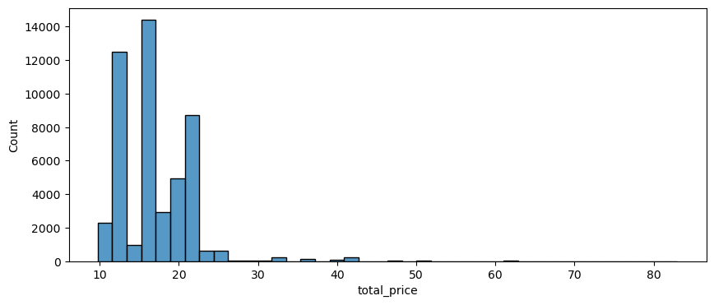

- Distribution is right skeewed - most of the orders between $10 - $25.
- Peak range $15 - $17 - most common price point.
- Very less orders exist in $30+ range.
- Outliers exist in range $50 - $85 - multiple quantity orders.

3.2 What is the distribution of quantity?
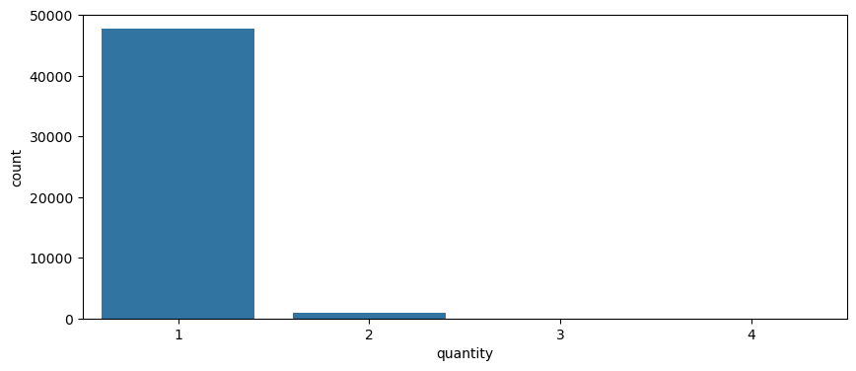

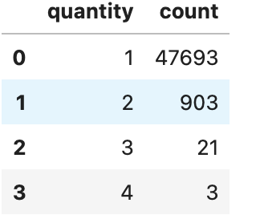

- 47,693 orders are for single pizza - most of the customers order just 1 pizza.
- 2, 3, 4 quantity very rare.
- Data heavily imbalanced - 1 quantity overwhelmingly dominant.

3.3 What is the distribution of unit_price?
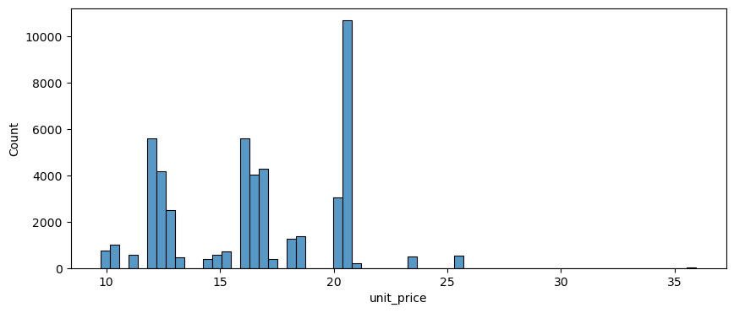

- $20.75 is the most common price - 8,685 orders
- $12.00 second most common price - 5600 orders
- $35.95 is least common price - only 28 orders
- Can divide into 3 cluster
  - Budget Cluster: $9.75 - $14.75
  - Standard Cluster: $15.25 - $18.50
  - Premium Cluster: $20.25 - $35.95

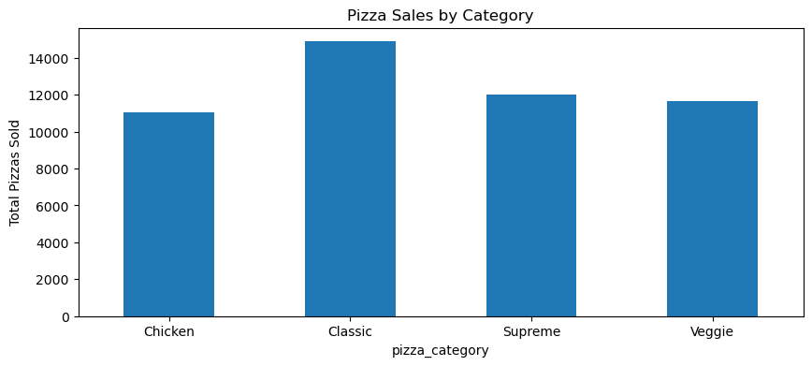
3.4 What is the value count of pizza_category?

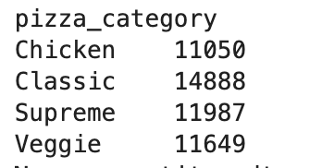

- Classic category sold highest total pizzas
- Chicken sold lowest among categories
- Category distribution relatively balanced
- Difference exists because some orders contain multiple pizzas

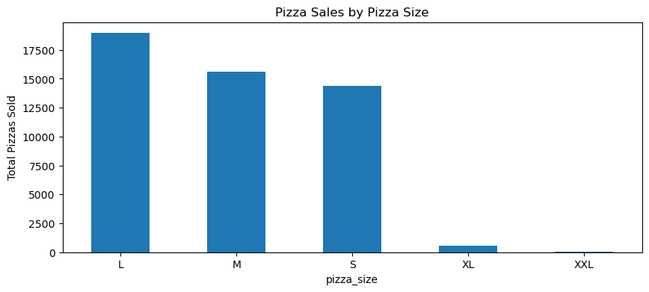
3.5 What is the value count of pizza_size?

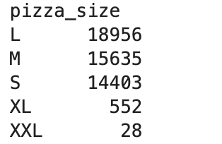

- Large(L) most popular - 18,956
- M & S near to same - balanced demand
- XL & XXL very low demand - 552 & 28
- Clear pattern: L > M > S >> XL >> XXL
- XL + XXL contribute only ~1.2% of total pizzas sold

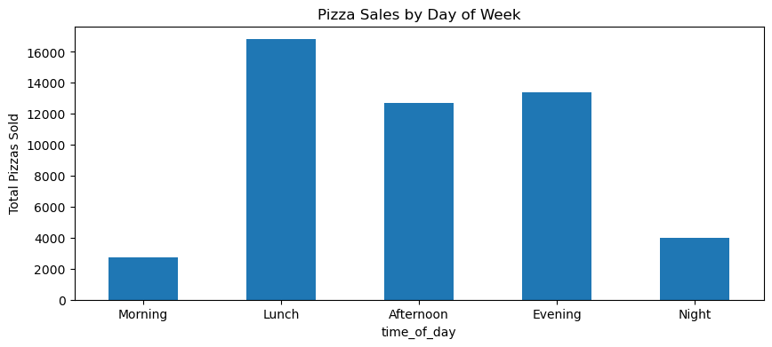
3.6 What is the value count of time_of_day?

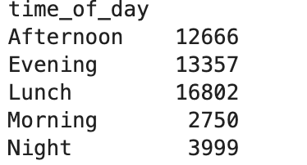

- Lunch is the busiest time - 16,802 pizzas sold
- Evening second - 13,357 pizzas sold
- Afternoon follows – 12,666 pizzas sold
- Night has lower demand – 3,999 pizzas sold
- Mornign is the least busiest time - 2,750 (fewer people eat pizza between 9 - 11AM)
- Peak time: Lunch + Evening
- These two periods contribute the majority of sales
- Morning demand is very low (early hours, low traffic)

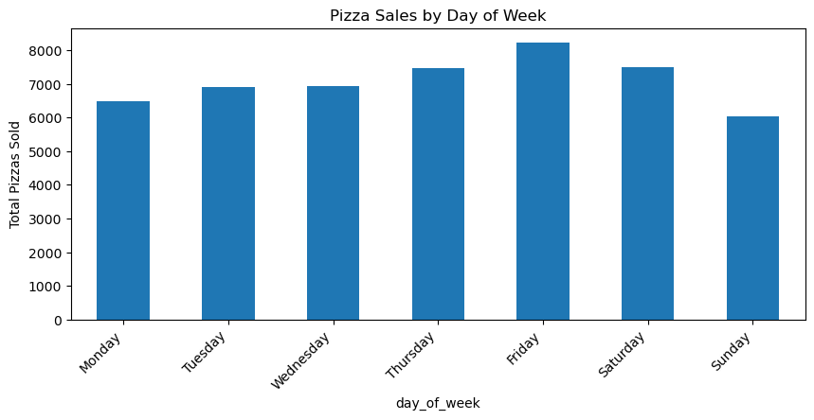
3.7 What is the value count of day_of_week?

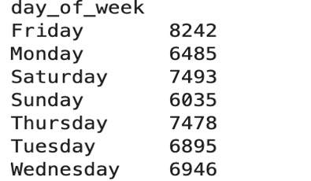

- Friday records the highest pizza sales(8242 units)
- Sunday shows the lowest demand (6035)
- Weekdays remain relatively stable with no extreame variation
- Slightly higher demand observed towards the end of the week.

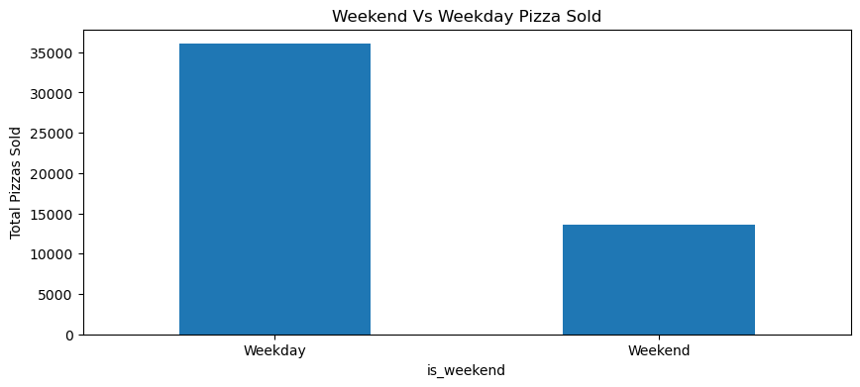
3.8 What is the distribution of is_weekend?

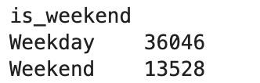

- Most of Pizzas sold in Weekday - 36,046
- In Weekend the number of pizza sold 13528 - near one third of Weekday's sold
- The reason of this Weekday = 5days and Weekend = 2days
- Per day average
  - Weekday: 36,046/5 = ~7209/day
  - Weekend: 13,528/2 = ~6764/day
- not a big difference on per day basis

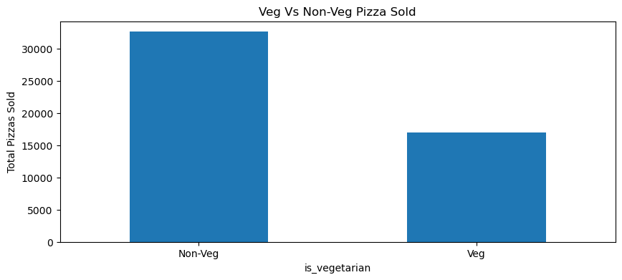
3.9 What is the value count of is_vegetarian?

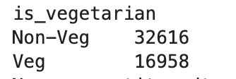

- Non-Veg most popular - 32616 pizza sold
- Veg only 16958 - nearly half of Non-Veg
- Ratio: Non-Veg 66% vs 34%
- Non-Veg dominant on the menu

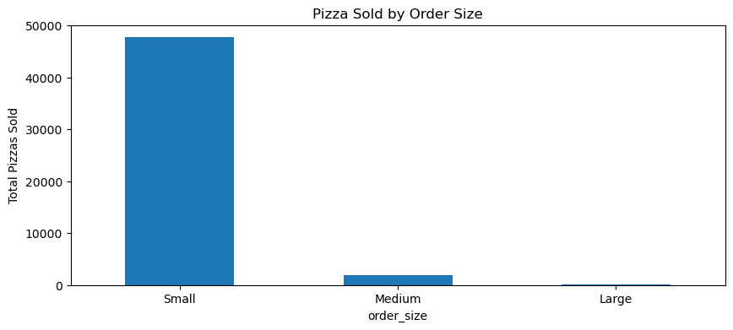
3.10 What is the value count of order_size?

order_size
Large 75
Medium 1806
Small 47693

- Small (qty=1) overwhelmingly dominant — 47,693 orders
- Medium (qty=2) only 1,806
- Large (qty=3+) only 75 — rare
- consistent with the result of Q2 — most of the customer order single pizza

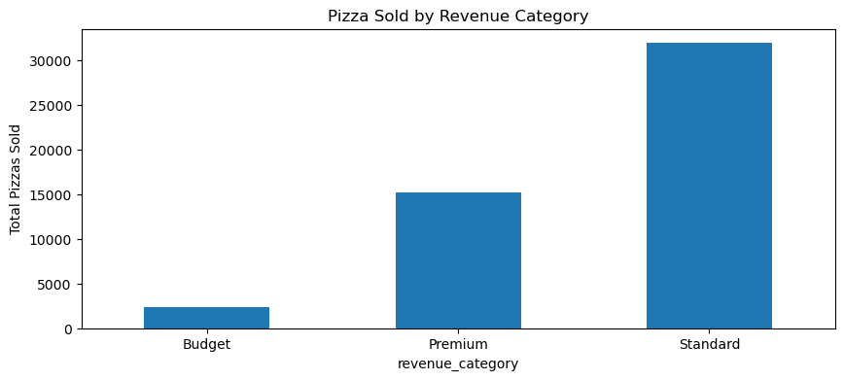
3.11 What is the distribution of revenue_category?

revenue_category
Budget 2349
Premium 15270
Standard 31955

- Standard revenue are the most - 31955 pizzas($12-$20 range)
- Premium Second - 15279 pizzas ($20+ range)
- Dudget are the least - only 2349 pizzas (under $12 range)
- Customer most of the time spend their money for Standard & Premium range
- Budget range not the that much popular - menu could be reconsider

4. Bivariate Analysis

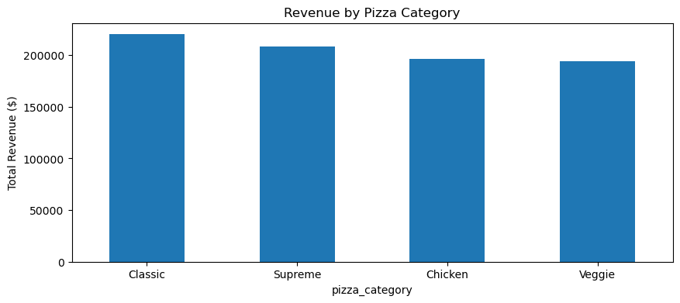
4.1 Which pizza category generates the most revenue?

pizza_category
Chicken 195919.50
Classic 220053.10
Supreme 208197.00
Veggie 193690.45

- Classic generate most of revenue — $220,053
- Supreme second — $208,197
- Chicken and Veggie nearly similar — ~$194K – $196K
- Not a big difference of revenue of all category - balanced revenue distribution
- Classic category top both quantity and revenue — consistent performer

4.2 Which pizza size generates the most revenue?

